Component
AI Blueprint
Name
AI_Runner
Data Structures
- AIPerception, for the sense of sight
- HasResource, a boolean value to determine if the AI is carrying a resource
- MemoryLocations, an array of vectors for the locations currently stored in memory
- PerceivedActor, an actor variable for storing whichever actor is currently being sensed by the AI
- CurrentMineVector, a vector of where the current mine being consumed is located
- LocationsMemorized, an integer value of how many cache locations have been memorized
- HasCurrentMine, a boolean value of whether or not the AI has spotted a current mine to consume

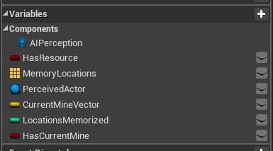
Algorithm
RandomWander:
- Moves to a location
  - Gets the controller, self is the input
  - Gets a random point in the radius
    - radius = 10000 units
    - Gets the current location of the actor to place the radius
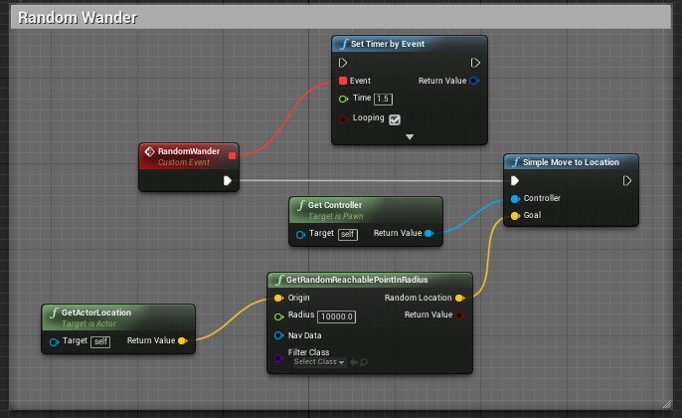
MineSource:
- Sets has resource to true
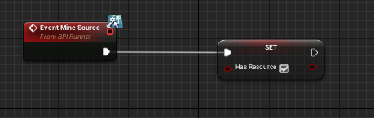
GoToCurrentMine:
- If HasCurrentMine
  - Move to the location of the current mine
    - Set the controller with self as the input
    - Set the goal as the vector location of the mine
- Endif
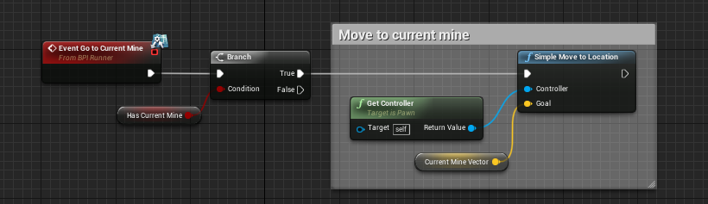
CheckKnownLocations:
- While LocationsMemorized >= the index
  - Move to the location
    - Set the controller with self as the input
    - Set the goal to the MemorizedLocations array of vectors using the index
  - Check for nearby mines
    - Use IsValidIndex
      - Get the currently perceived actors
        - Sense = sight
        - Target = AIPerception
  - Increment the index
- Endloop
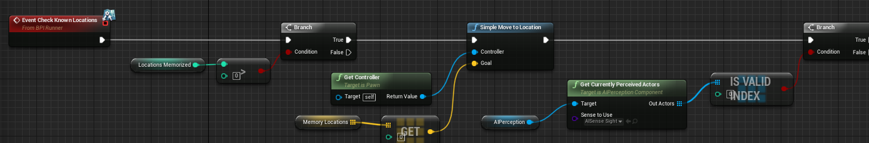
SetCurrentMineToFalse:
- Set HasCurrentMine to false
- Set CurrentMineVector to (0, 0, 0)
- Call CacheFalse
  - Get all the actors of the interface
    - Interface is BPI_Runner
  - For Each Loop node
    - Place array element into target input of CacheFalse
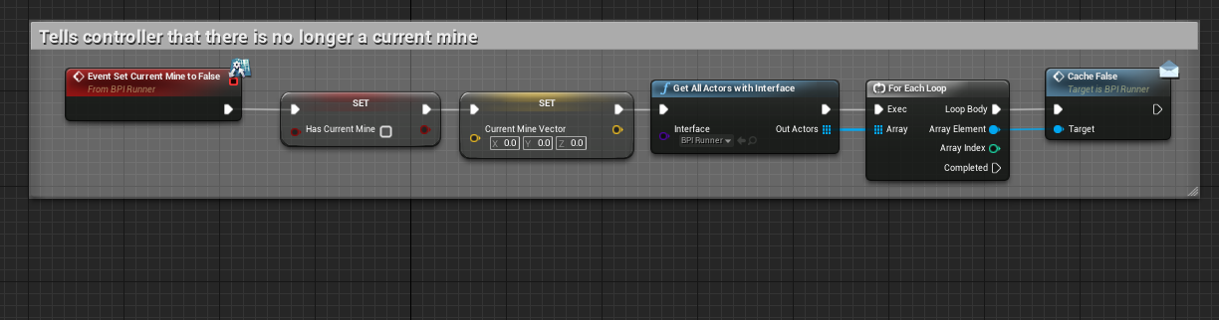
OnTargetPerceptionUpdated (AIPerception):
- Set PerceivedActor
  - Use the Actor parameter
- If SuccessfullySensed (using Break AIStimulus)
  - Set CurrentMineVector to the stimulus’s location
  - Set HasCurrentMine to true
  - Call CacheTrue
  - Get all the actors of the interface
    - Interface is BPI_Runner
  - For Each Loop node
    - Place array element into target input of CacheTrue
  - If CurrentMineVector is contained in the MemoryLocations array of vectors
    - Update CurrentMineKey (a blueprint key)
      - Get the controller with self as the input
        - Cast to AIC_Runner (the controller BP)
      - CurrentMineVector for the target
  - Else
    - Add the CurrentMineVector to the MemoryLocations
    - Increment the LocationsMemorized
    - Update CurrentMineKey
      - Get the controller with self as the input
        - Cast to AIC_Runner (the controller BP)
      - CurrentMineVector for the target
  - endif
- endif
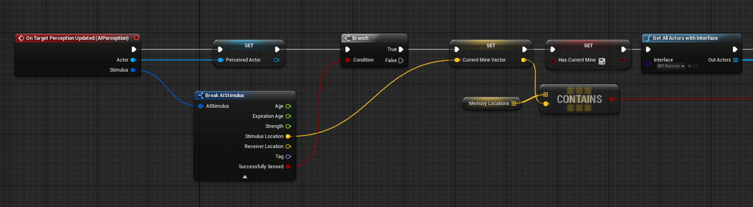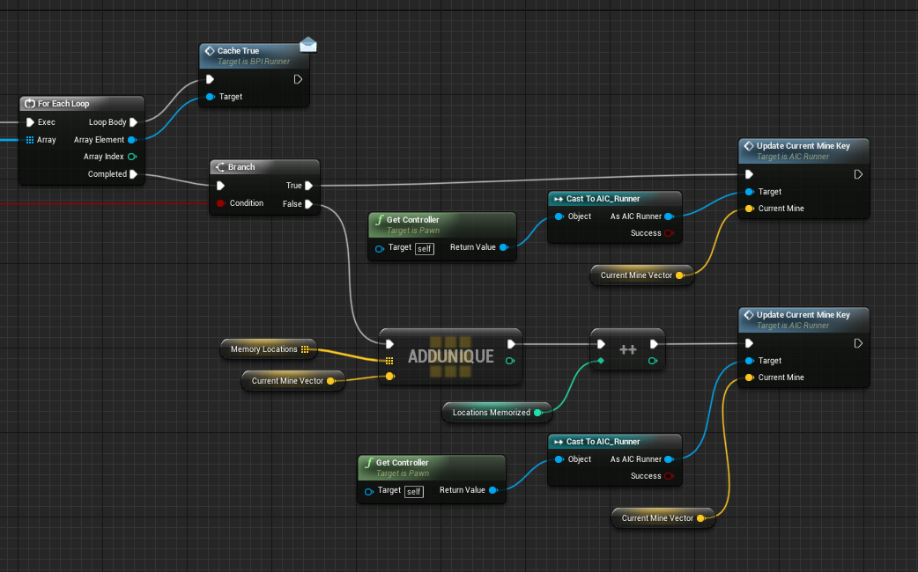

Communication
- This blueprint uses the blueprint interface: BPI_Runner
- This blueprint calls CacheFalse found in BTT_GoToCurrentMine through the interface
- This blueprint calls CacheTrue found in BTT_GoToCurrenMine through the interface
- This blueprint allows other blueprints to call several events found inside\
- This blueprint uses the AI Controller: AIC_Runner

Component
AI Controller Blueprint
Name
AIC_Runner
Data Structures
- CurrentMineName, a Name variable type for the key name to add to the blackboard

Algorithm
OnPossess:
- Run Behavior Tree
  - Target = self
  - BTAsset = BT_Runner
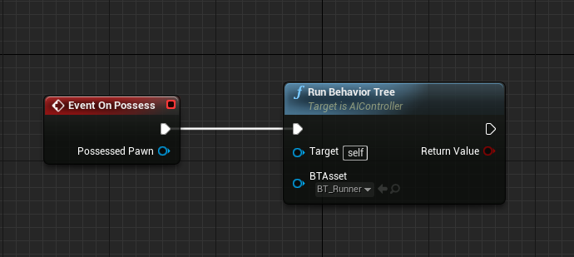
UpdateCurrentMineKey:
- Set Value as Vector
  - Set the target to the blackboard
  - Set the key name to the CurrentMineName
  - Set the VectorValue to the CurrentMine parameter from the UpdateCurrentMineKey node
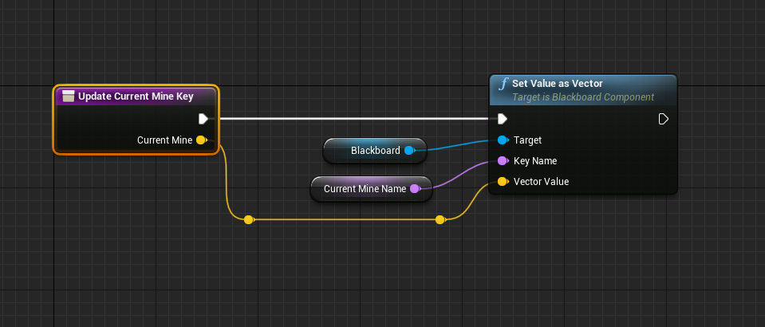
Communication
- This is primarily used with the AI blueprint: AI_Runner

Component
Blackboard
Name
BB_Runner
Data Structures
- TargetMine, object key for the cache
- TargetHome, vector key for home
- SelfActor, object key for self
- CurrentMine, vector key for the location of the cache
- TargetLocation, vector key for the location to move randomly
- CacheSet, boolean key to tell if there is a cache being used
- CurrentCharges, integer key for the amount of charges left on the current mine
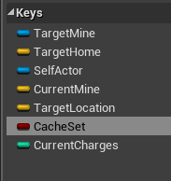
Algorithm
- Interacts heavily with the behavior tree
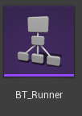
Communication
- The blackboard communicates heavily with the behavior tree
- The data structures are changed and updated in tasks

Component
Behavior Tree
Name
BT_Runner
Data Structures
- Interacts heavily with the Blackboard: BB_Runner
- Uses Tasks
  - BTT_Mined, task when a cache is mined
  - BTT_CheckKnownLocations, task to check the locations stored in memory
  - BTT_GoHome, task to go home
  - BTT_RandomWander, task to randomly wander around in search for a cache
  - BTT_GoToCurrentMine, task to go to the current mine
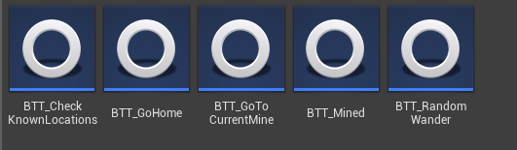
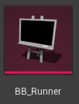
Algorithm
- Root
  - Selector
    - Selector
      - UseCurrentMine - sequence
        - BTT_GoToCurrentMine
          - Goes to the current mine
        - Run EQS Query
          - EQS_FindNearestMine
          - Result Key: TargetMine
        - Move To: TargetMine
        - Wait: 3 seconds
        - BTT_Mined
          - Mines the current cache
        - BTT_GoHome
        - Move To: TargetHome
        - Wait: 3 seconds
      - CheckKnownMines - sequence
        - BTT_CheckKnownLocations
          - Checks the locations in memory for caches
        - Run EQS Query
          - EQS_FindNearestMine
          - ResultKey: TargetMine
        - Move To: TargetMine
        - Wait: 3 seconds
        - BTT_Mined
          - Mines the current cache
        - BTT_GoHome
        - Move To: TargetHome
        - Wait: 3 seconds
      - FindMine – sequence
        - Run EQS Query
          - EQS_FindNearestMine
          - ResultKey: TargetMine
        - Move To: TargetMine
        - Wait: 3 seconds
        - BTT_Mined
          - Mines the current cache
        - BTT_GoHome
        - Move To: Target Home
        - Wait: 3 seconds
    - WanderAround – sequence
      - BTT_RandomWander
      - Move To: TargetLocation
      - Wait: 1 second
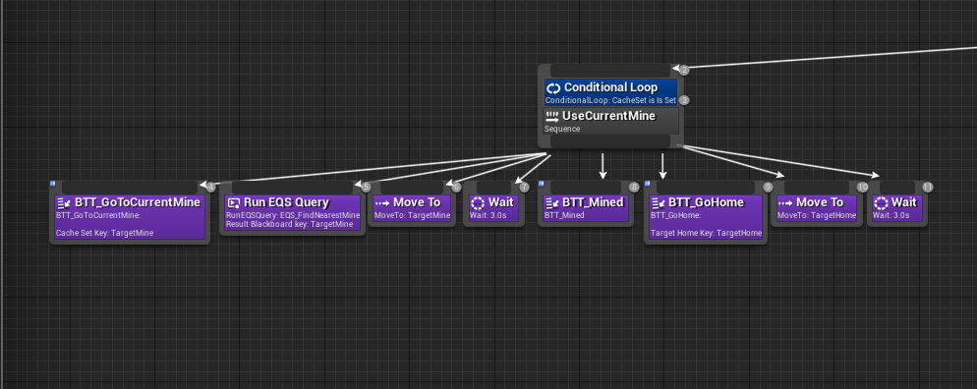
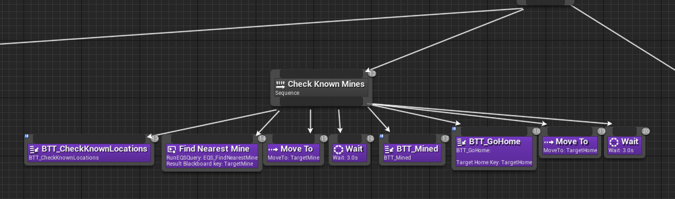
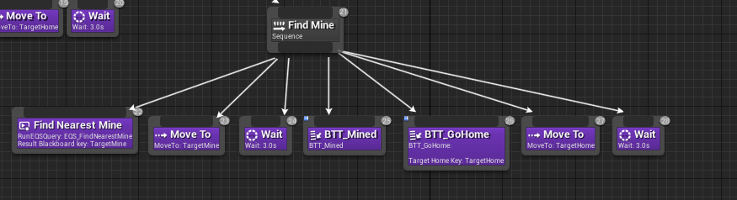
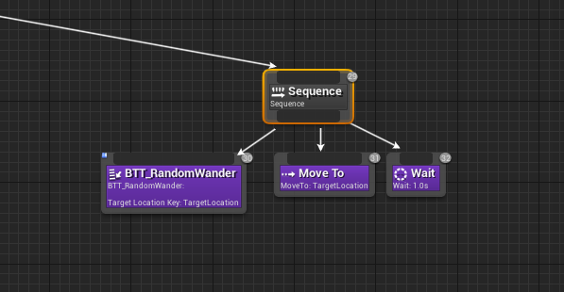

Communication
- The behavior tree heavily communicates with the blackboard
- Controls the AI logic: AI blueprint and AI Controller blueprint
- Uses several tasks to complete the logic

Component
A task
Name
BTT_CheckKnownLocations
Data Structures
None
Algorithm
ReceiveExecuteAI:
- Get All Actors with the Interface
  - Interface: BPI_Runner
- For Each Loop
  - Place array element into target input of CheckKnownLocations
- Call CheckKnownLocations through the blueprint interface
  - CheckKnownLocations can be found in AI_Runner
- Finish Execute
  - Target is self
  - Success is true
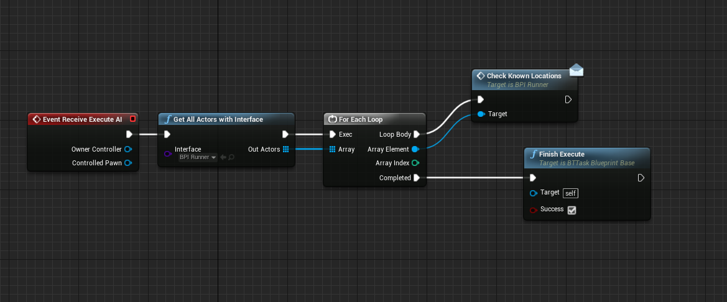
Communication
- As a task, used in the behavior tree
- Calls a function from another blueprint, AI_Runner
- Uses the blueprint interface: BPI_Runner

Component
A task
Name
BTT_GoHome
Data Structures
- TargetHomeKey, a public blackboard key for the target home
- HomeLocation, a vector of the location home is found
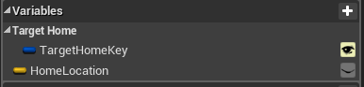
Algorithm
ReceiveExecuteAI:
- Set Blackboard Value as a vector
  - Key is TargetHomeKey of category TargetHome
  - Value is HomeLocation
- Finish Execute
  - Target = self
  - Success = true
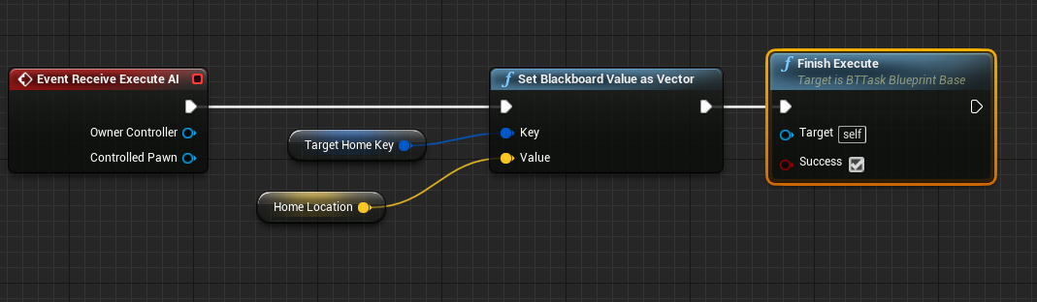
Communication
- As a task, communicates with the behavior tree
- Sets a value in the blackboard
- Is connected to the blueprint interface: BPI_Runner

Component
A task
Name
BTT_Mined
DataStructures
None
Algorithm
ReceiveExecuteAI:
- Get All Actors with the Interface
  - Interface: BPI_Runner
- For Each Loop
  - Place array element into target input of Mined
- Call Mined through the blueprint interface
  - Mined can be found in Mine_Source
- Finish Execute
  - Target is self
  - Success is true
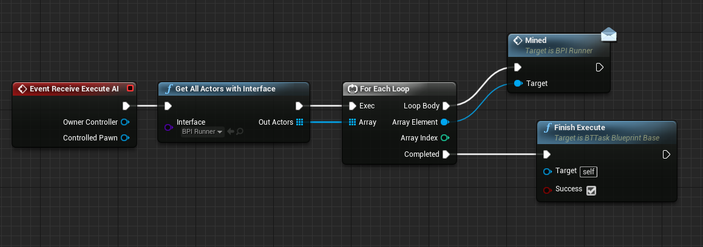
Communication
- As a task, communicates with the behavior tree
- Is connected to the blueprint interface: BPI_Runner
- Calls an event from Mine_Source through the blueprint interface

Component
A task
Name
BTT_GoToCurrentMine
Data Structures
- CacheSetKey, a public blackboard key for checking if the cache is set
- IsCacheSet, a boolean variable to take the output from the two events
Algorithm
ReceiveExecuteAI:
- Get All Actors with the Interface
  - Interface: BPI_Runner
- For Each Loop
  - Place array element into target input of GoToCurrentMine
- Call GoToCurrentMine through the blueprint interface
  - GoToCurrentMine can be found in AI_Runner
- Set a blackboard value as a bool
  - The key is CacheSetKey
  - Value is IsCacheSet
- Finish Execute
  - Target is self
  - Success is true
CacheTrue:
- Set IsCacheSet to true
CacheFalse:
- Set IsCacheFalse to false
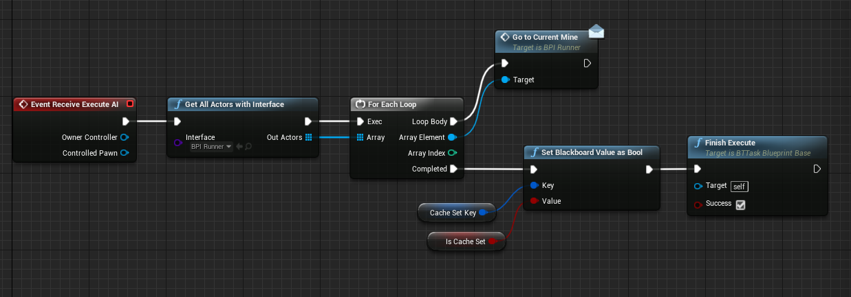
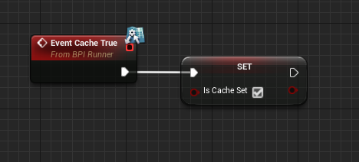
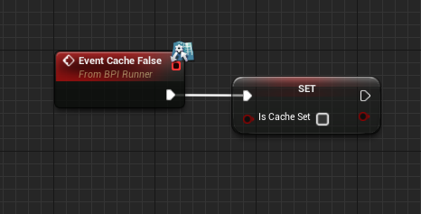
Communication
- As a task, communicates with the behavior tree
- Uses the blueprint interface: BPI_Runner
- Calls GoToCurrentMine from AI_Runner
- Interacts with the blackboard by setting a value for one of the keys

Component
A task
Name
BTT_RandomWander
Data Structures
- TargetLocationKey, a public blackboard key to set a location to wander to
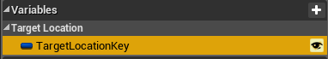
Algorithm
ReceiveExecuteAI:
- Set a blackboard value as a vector
  - Get a random reachable point in the radius for the value
    - Origin = return value of GetActorLocation
      - Target = the controlled pawn parameter
    - Radius = 10000
  - Key = TargetLocationKey
- Finish Execute
  - Target = self
  - Success = return value of GetRandomReachablePointInRadius
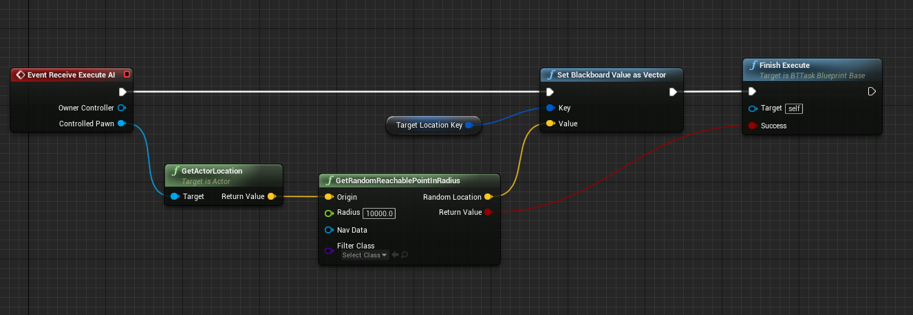
Communication
- As a task, communicates with behavior tree
- Set a blackboard key to a value
- Executes an AI action
Component
EQS
Name
EQS_FindNearestMine
Data Structures
- Distance Test, used to check the distance between the actor and the querier
Algorithm
- Root
  - Actors of class
    - Generates sets of actors around of Mine_Source
    - 1000 search radius
  - Distance test
    - Prefers lesser
    - Score only
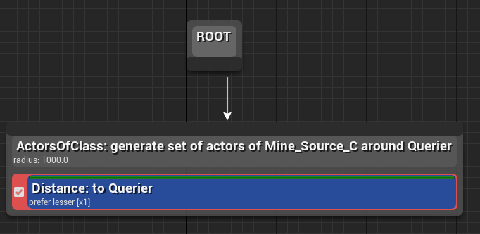
Communication
- Is used in the behavior tree to query
- Lets the AI search for specific actors
- Uses the actor Mine_Source for the query
Component
Blueprint Class
Name
Mine_Source
Data Structures
- AIPerceptionStimuliSource, a sight stimuli for AI to sense
- Cube, the mesh for the blueprint
- DefaultSceneRoot, the root for the blueprint
- Charges, the amount of charges the source has left before being depleted
- MaxCharges, the maximum amount of charges the source had, randomly generated from 3-5
- OriginalScale, a vector for the original scale of the cube to be changed as charges are depleted
Algorithm
Mined:
- Decrement the charges
- Get All Actors with the Interface
  - Interface: BPI_Runner
- For Each Loop
  - Place array element into target input of MineSource
- Call MineSource through the blueprint interface
  - MineSource can be found in AI_Runner
- If Charges <= 0
  - Destroy the actor
  - Get All Actors with the Interface
    - Interface: BPI_Runner
  - For Each Loop
    - Place array element into target input of SetCurrentMineToFalse
  - Call SetCurrentMineToFalse through the blueprint interface
    - SetCurrentMineToFalse can be found in AI_Runner
  - Get All Actors with the Interface
    - Interface: BPI_Runner
  - For Each Loop
    - Place array element into target input of SpawnNewMine
  - Call SpawnNewMine through the blueprint interface
    - SpawnCurrentMine can be found in ThirdPersonGameMode
- Else
  - Set the relative scale of the box
    - Target = Cube
    - New Scale 3D = OriginalScale*(Charges/MaxCharges)
- endif
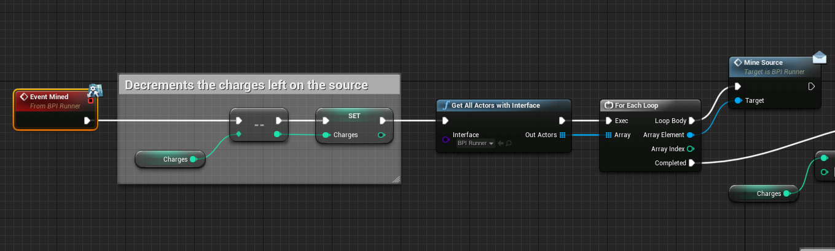
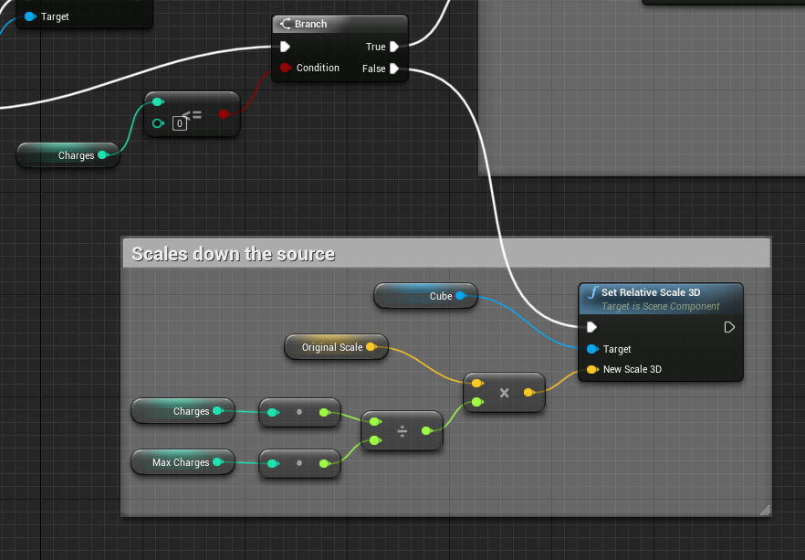
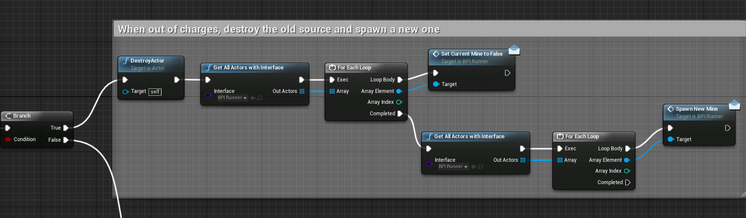
Communication
- This communicates with the AI due to its interaction
- Is used in the EQS: EQS_FindNearestMine
- Event calls to AI_Runner
- Event call to ThirdPersonGameMode
- Event called from a task
- Referenced in the behavior tree
- Mine Sources referenced in the blackboard
- Found in the map in set locations

Component
Blueprint Interface
Name
BPI_Runner
Data Structures
Functions:
- SpawnNewMine, spawns a new cache
- MineSource, mines the source
- Mined, enacts the results of mining the source
- SetCurrentMineToFalse, Changes several values as to reset the current mine
- CheckKnownLocations, checks the memorized locations for caches
- GetCurrentCharges, Send the current amount of charges on the mine source
- CacheFalse, sets the IsCacheSet to false
- CacheTrue, sets the IsCacheSet to true
- GoToCurrentMine, goes to the current mine
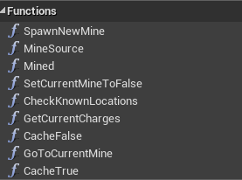
Algorithm
N/A
Communication
- The blueprint interface is all about the communication
- Communicates with almost every component in the project as to allow functions to be called across blueprints

Component
Game Mode
Name
ThirdPersonGameMode
Data Structures
- DefaultSceneRoot, Root for the blueprint
- SpawnLocations, array of vectors for the spawn locations of the mine sources
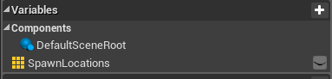
Algorithm
BeginPlay:
- Call SpawnNewMine
  - SpawnNewMine Found in this blueprint
SpawnNewMine
- Spawn an actor
  - Class = Mine_Source
  - Spawn Transform Location
    - Get a random integer in range
      - 0 to the length of SpawnLocations -1
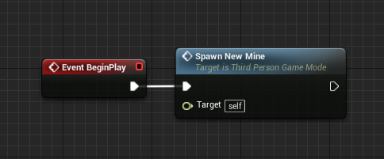
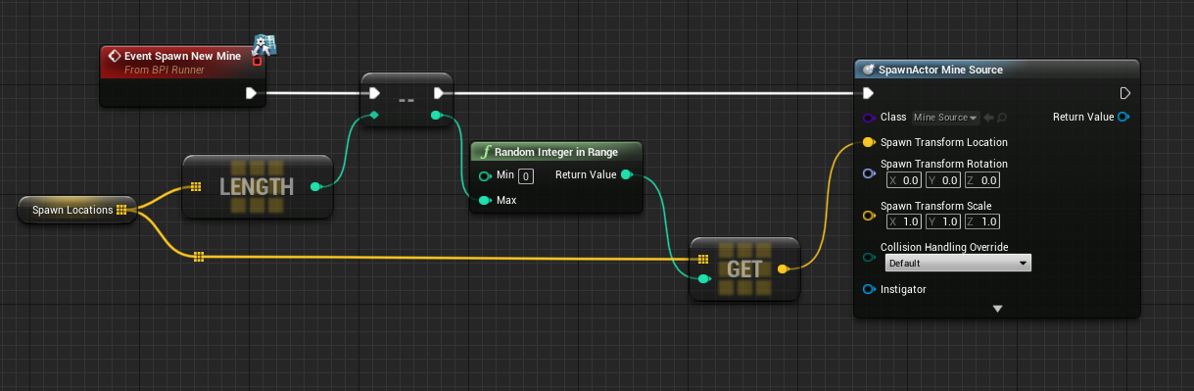
Communication
- As the GameMode for the level, this technically is communicating with pretty much everything
- Communicates specifically with the Mine_Source actor, by spawning it
- SpawnNewMine is called from Mine_Source

